**Configuring the Jenkins :**

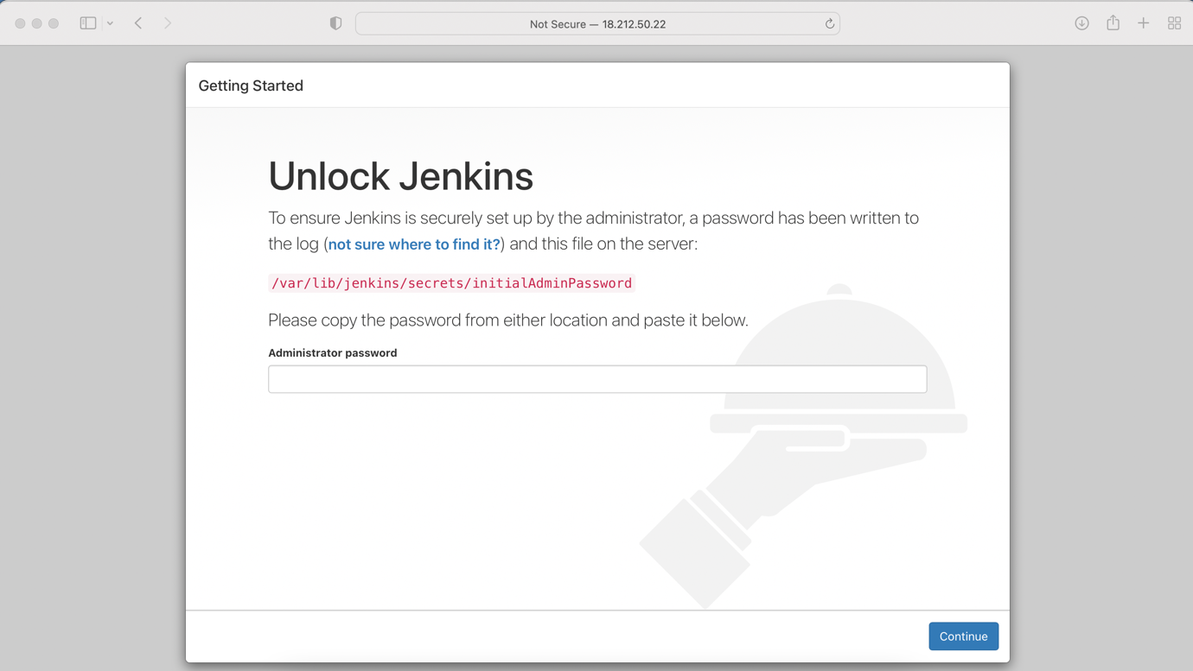

We can get the password will installation of Jenkins completed

sudo cat /var/lib/jenkins/secrets/initialAdminPassword

Please follow the below screenshots to configure the Jenkins

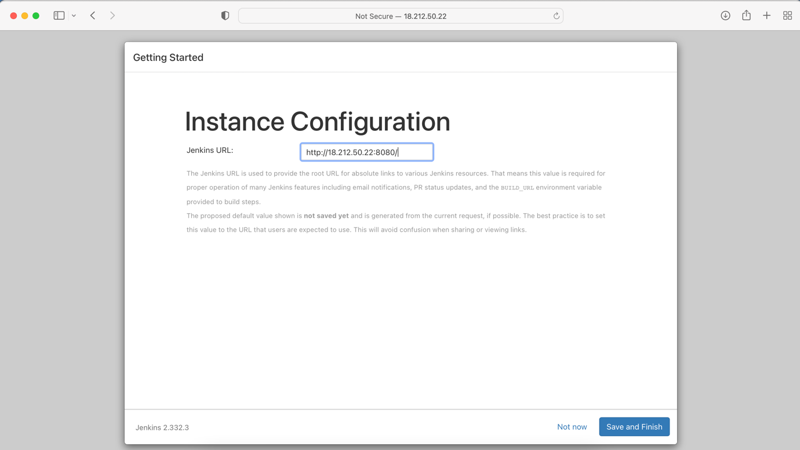

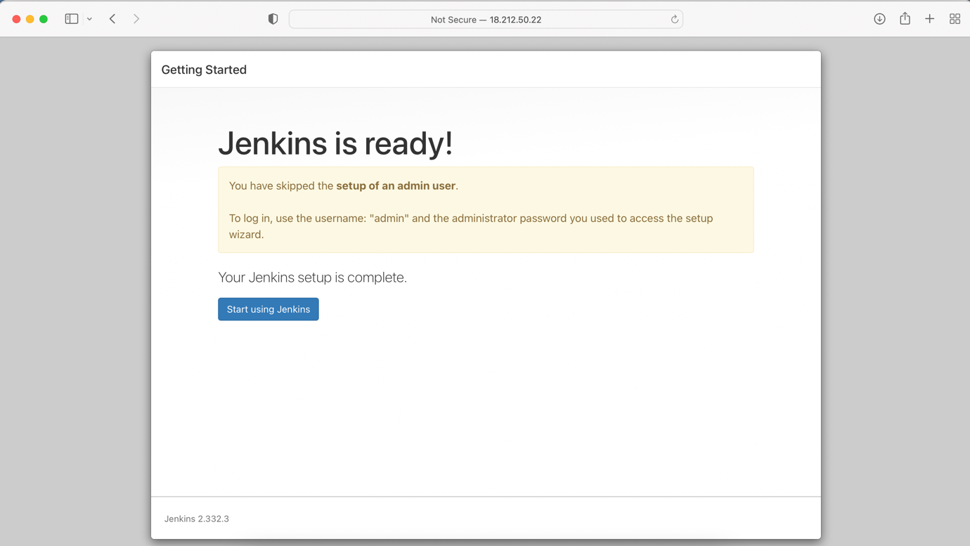

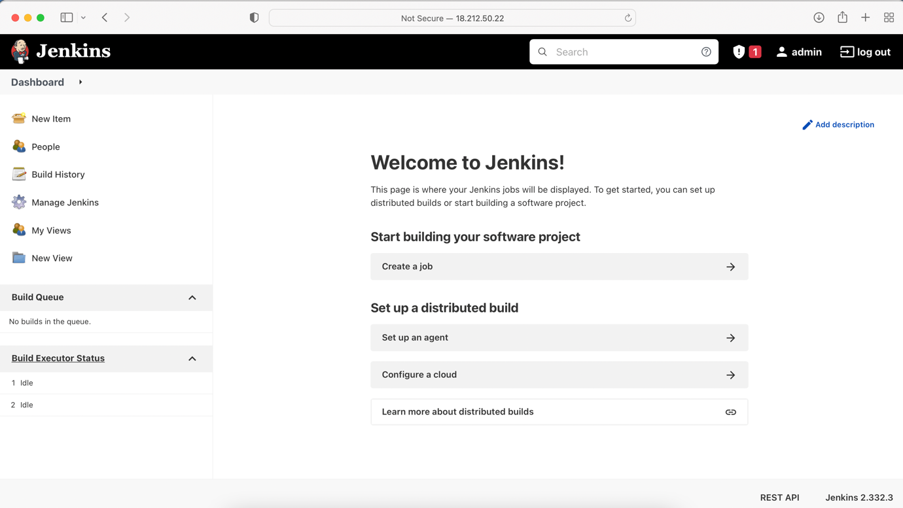

Install the docker plugins from the plugin manger.

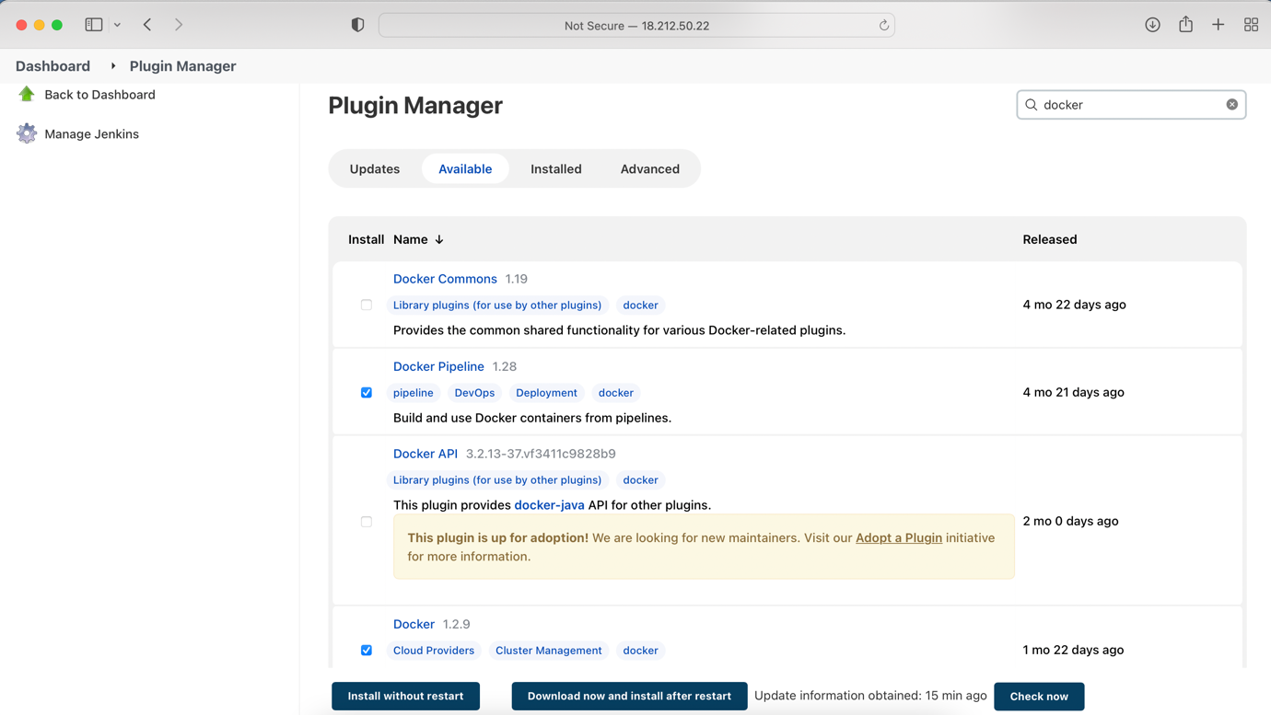

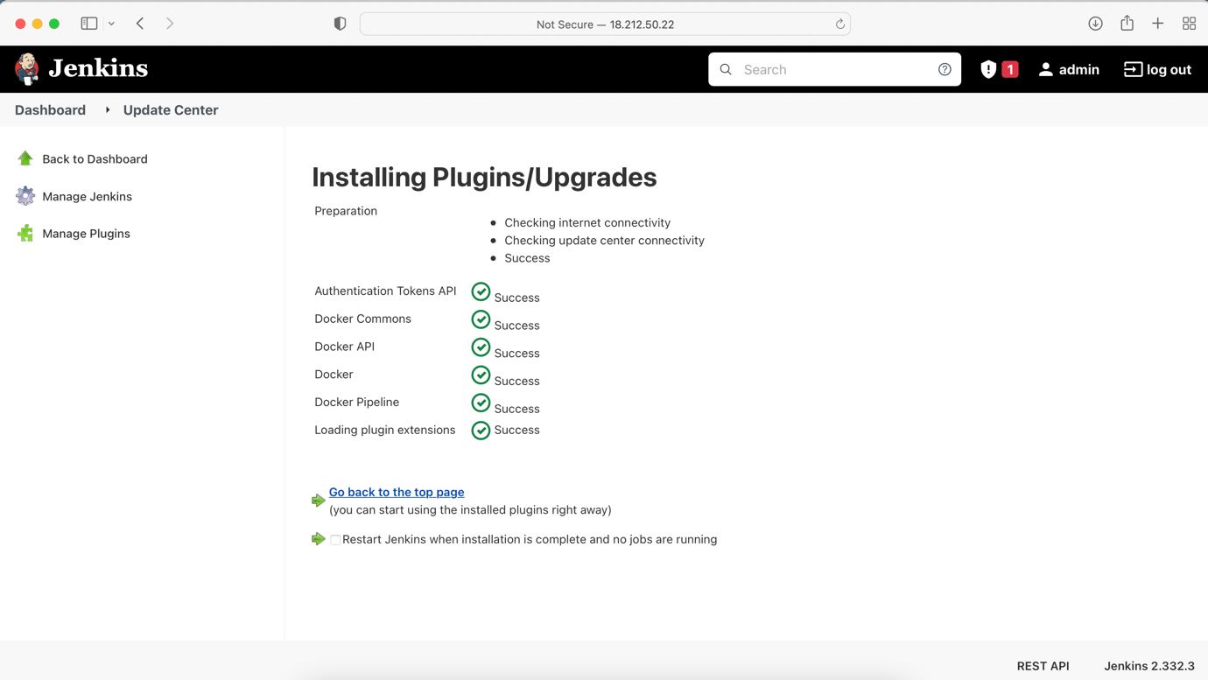

**Step 1 – Create a pipeline in Jenkins, with project name**

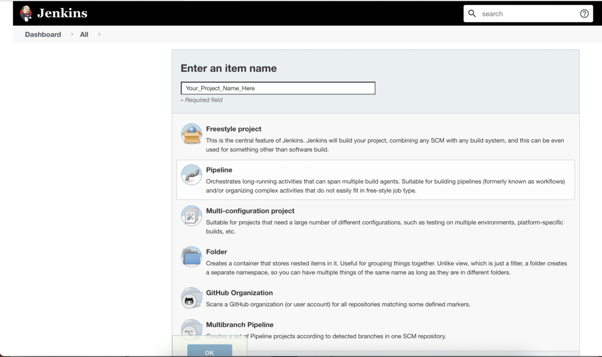

**Step 2: Use below pipeline code**

pipeline { agent any environment { AWS_ACCOUNT_ID="YOUR_ACCOUNT_ID_HERE" AWS_DEFAULT_REGION="CREATED_AWS_ECR_CONTAINER_REPO_REGION" IMAGE_REPO_NAME="ECR_REPO_NAME" IMAGE_TAG="IMAGE_TAG" REPOSITORY_URI = "${AWS_ACCOUNT_ID}.dkr.ecr.${AWS_DEFAULT_REGION}.amazonaws.com/${IMAGE_REPO_NAME}" } stages { stage('Logging into AWS ECR') { steps { script { sh "aws ecr get-login-password --region ${AWS_DEFAULT_REGION} | docker login --username AWS --password-stdin ${AWS_ACCOUNT_ID}.dkr.ecr.${AWS_DEFAULT_REGION}.amazonaws.com" } } } stage('Cloning Git') { steps { checkout([$class: 'GitSCM', branches: [[name: '*/main']], doGenerateSubmoduleConfigurations: false, extensions: [], submoduleCfg: [], userRemoteConfigs: [[credentialsId: '', url: ' https://github.com/sirishrayaprolu/webapp-orderbird.git']]]) } } // Building Docker images stage('Building image') { steps{ script { dockerImage = docker.build "${IMAGE_REPO_NAME}:${IMAGE_TAG}" } } } // Uploading Docker images into AWS ECR stage('Pushing to ECR') { steps{ script { sh "docker tag ${IMAGE_REPO_NAME}:${IMAGE_TAG} ${REPOSITORY_URI}:$IMAGE_TAG" sh "docker push ${AWS_ACCOUNT_ID}.dkr.ecr.${AWS_DEFAULT_REGION}.amazonaws.com/${IMAGE_REPO_NAME}:${IMAGE_TAG}" } } } } }

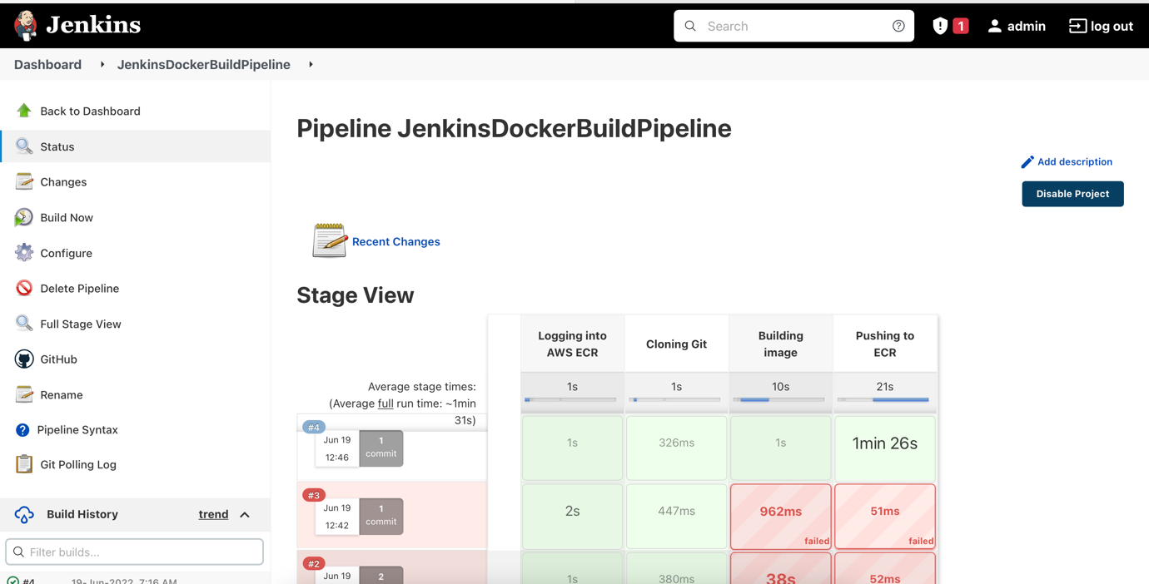

ECR ([Amazon Elastic Container Registry](https://us-east-1.console.aws.amazon.com/ecr/get-started?region=us-east-1))

Once the pipeline is completed we can view the image in the ECR

